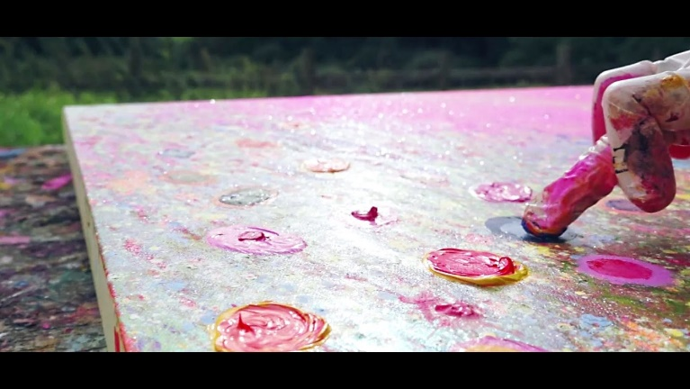
Painting like Yvonne Coomber
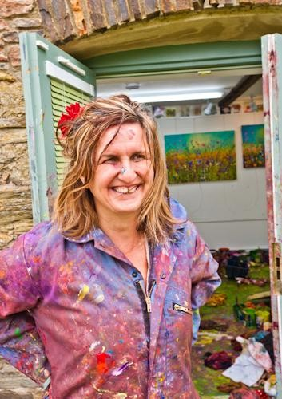
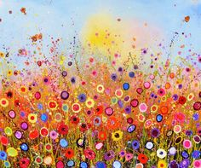
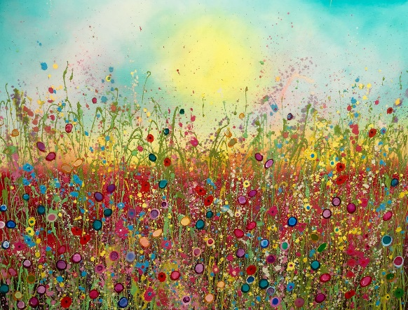
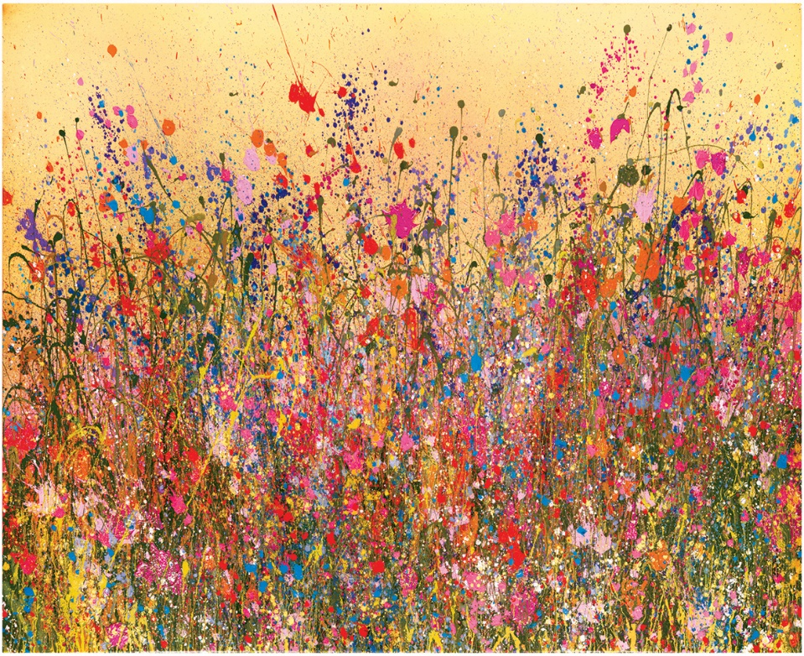
How to paint like Yvonne Coomber
You will need:
- An old toothbrush
- Paint (craft paint like acrylic)
- A paint brush
- A canvas/piece of thick paper
- Pot of water (you’ll need lots)
This is a messy job, we recommend a plastic matt and some old clothing. Do the painting in your garden.

- Paint a background with a green meadow, blue sky and a yellow sun. Use paint with lots of moisture. Use a sponge to make the sun, dip the sponge in really wet paint then put it on the painting; or you can paint a round sun.
- Leave it to dry.
- Take green paint and make sure it is very wet. Then get an old toothbrush and use your thumb to hold the toothbrush and flick downwards onto the canvas. If the spots are too big, with a tissue/toilet roll dab the spot. Leave to dry. We didn’t and our flowers turned the canvas a bit brown.
- Next, we got a couple of colours to represent the flowers. We used purple, yellow, blue, red.
- Use your cleaned toothbrush and pick a colour. Then flick onto the canvas. Do one colour at a time. After each colour, wash your toothbrush. Don’t mix colours with your toothbrush, mix with a paintbrush.
- Dot use too much paint to flick, just a little bit of each colour.
- Leave it to dry, again!
- With the same colours we used to splatter the painting. Do some little dots. Bigger at the bottom and smaller at the top. Not too big! Bigger are close, smaller are further away – this is called perspective.
- Make sure the dots are still a bit wet, then paint little dots to make them look like the core of the flower. We used back paint in the centre of red dots to represent poppys.
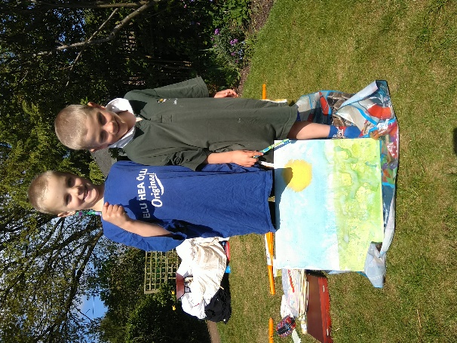
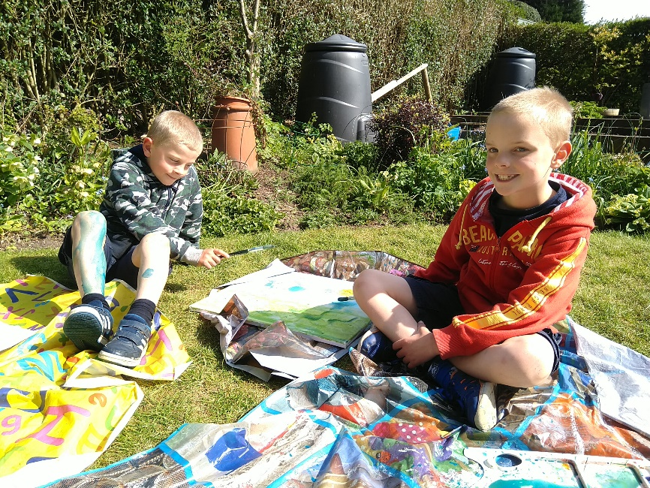
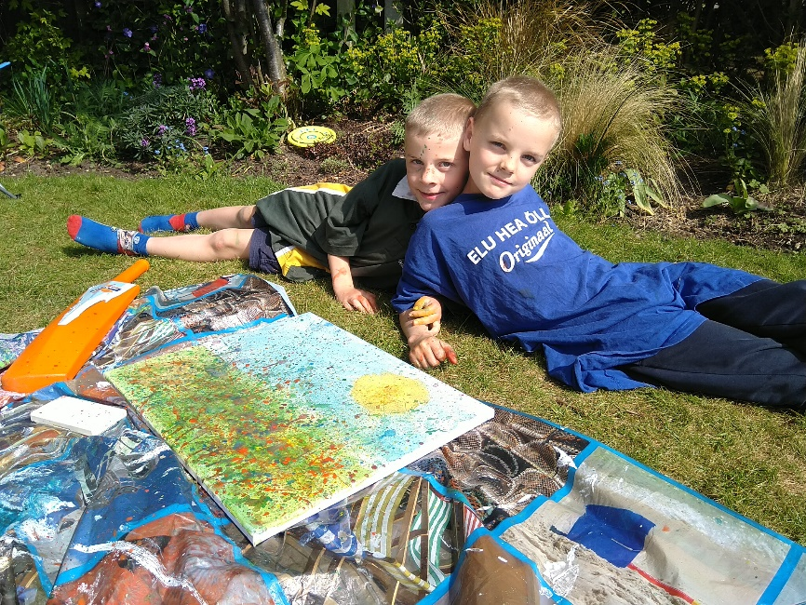
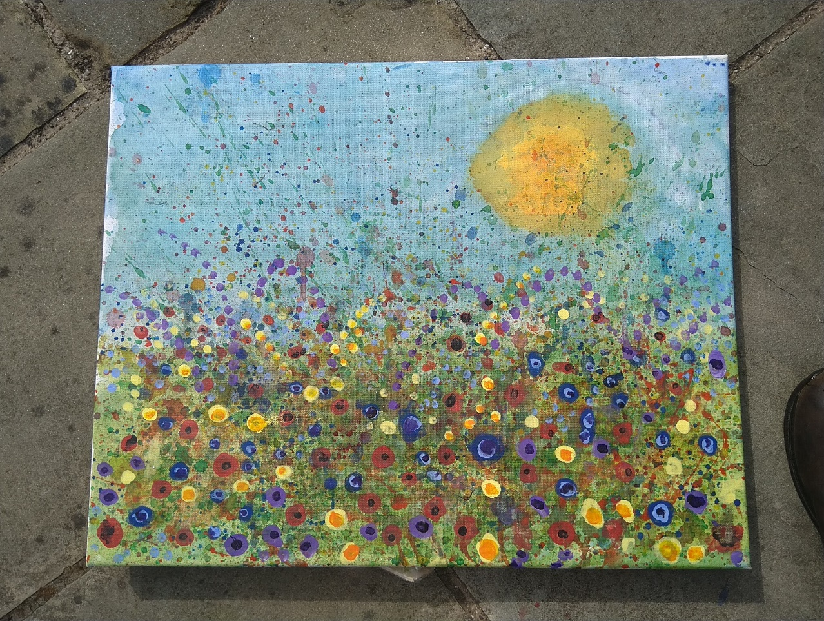
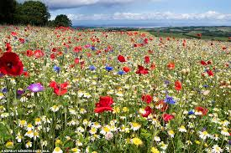
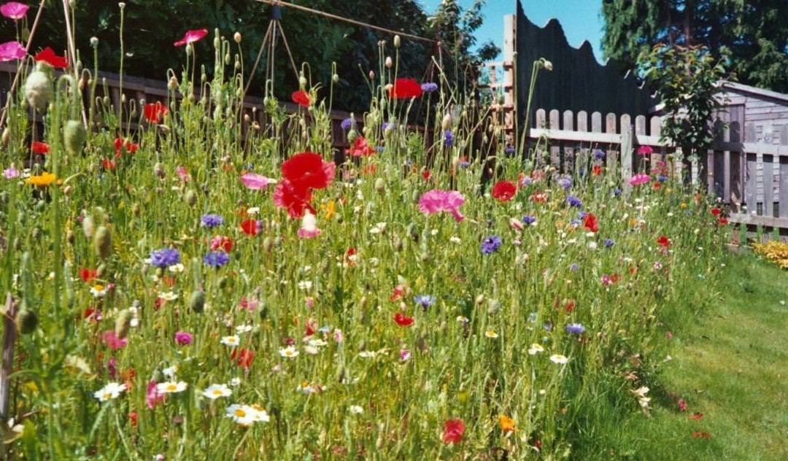
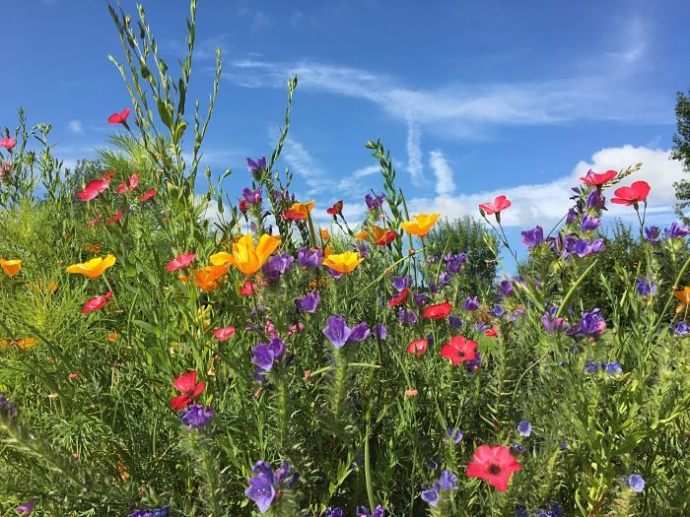
Real Wildflower Meadows
Important for bees, there are lots of flowers to provide food for bees.
Without bees we would die, that is why we need these meadows.
We have less and less meadows because farming is using land for crops and not letting the wildflowers grow.

